Name: Anushka Shailesh Gokhale.
Class: TY BTech CSE
Panel: H
Batch: H1
PRN: 1032231383
Roll no.: 09

Assignment 04

Title: Support Vector Machine (SVM) Classifier and comparison with Tree based classifier
Aim: To perform SVM classification using Python and compare it with tree based classifier.
Objectives: To implement SVM classifier and perform comparison with Decision Tree.

Problem Statement: Implementation of SVM. Comparison with tree based classifier.

Algorithm: SVM, Decision Tree

SVM:
Support vector machine is highly preferred by many as it produces significant accuracy with less computation power. Support Vector Machine, abbreviated as SVM can be used for both regression and classification tasks. But, it is widely used in classification objectives.

- The line that maximizes the minimum margin is a good best.
- This maximum-margin separator is determined by a subset of the data points.
  - Data points in this subset are called “support vectors”.
  - It will be useful computationally if only a small fraction of the data points are support vectors
  - The support vectors are used to decide which side of the separator a test case is on.
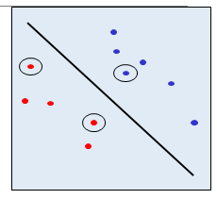
Fig.1 Support vectors are indicated by circles around them

Hyper-planes are decision boundaries that help classify the data points. Data points falling on either side of the hyperplane can be attributed to different classes. Also, the dimension of the hyperplane depends upon the number of features. If the number of input features is 2, then the hyperplane is just a line. If the number of input features is 3, then the hyperplane becomes a two-dimensional plane. It becomes difficult to imagine when the number of features exceeds 3.

Main Idea behind the kernel function:
1. Starts with data in low dimension.
2. Moves the data into a higher dimension if it is not linearly separable by a hyperplane.
3. Finds the Support Vector Classifier (hyperplane) that separates the higher dimensional data into two groups.

SVM (Support Vector Machines) and decision tree algorithms are both commonly used in machine learning for classification tasks. However, they differ in their approach to classification and their strengths and weaknesses.
Here are some of the key differences between SVM and decision tree algorithms:
Approach to classification:
SVM: SVM is a discriminative classifier that separates the data points into different classes using a hyperplane. It tries to find the hyperplane that maximizes the margin between the different classes.
Decision Tree: Decision tree is a type of classification algorithm that builds a tree-like model of decisions and their possible consequences. It uses a tree structure to partition the data into different classes based on the values of the input features.
Handling non-linearly separable data:
SVM: SVM can handle non-linearly separable data by using a technique called kernel trick, which maps the input data to a higher-dimensional feature space where the data becomes separable.
Decision Tree: Decision tree may not be able to handle non-linearly separable data very well. It may require pre-processing or feature engineering to make the data separable.
Interpretability:
SVM: SVM is not very interpretable. It provides a black-box model that is difficult to understand and explain.
Decision Tree: Decision tree is more interpretable than SVM. It provides a tree-like structure that can be easily visualized and understood.
Overfitting:
SVM: SVM is less prone to overfitting because it tries to maximize the margin between the different classes, which leads to a simpler decision boundary.
Decision Tree: Decision tree is more prone to overfitting because it can create complex decision boundaries that may not generalize well to new data.

To compare SVM and decision tree algorithms, we can conduct experiments on a dataset and evaluate their performance on various metrics such as accuracy, Mean square error. Here is an example of how we can compare the performance of SVM and decision tree algorithms on a dataset:

We will use the breast cancer dataset from scikit-learn library. This is a binary classification problem where we need to predict whether a patient has malignant or benign breast cancer based on various features

CODE:
import pandas as pd
import numpy as np
import matplotlib.pyplot as plt
import seaborn as sns

from sklearn.datasets import load_iris
from sklearn.model_selection import train_test_split, cross_val_score
from sklearn.preprocessing import StandardScaler, LabelEncoder
from sklearn.tree import DecisionTreeClassifier, plot_tree
from sklearn.svm import SVC
from sklearn.metrics import (accuracy_score, classification_report,
confusion_matrix, ConfusionMatrixDisplay)

print("✅ All libraries imported successfully.")

iris = load_iris()
df = pd.DataFrame(iris.data, columns=['sepal_length', 'sepal_width', 'petal_length', 'petal_width'])
df['species'] = pd.Categorical.from_codes(iris.target, iris.target_names)

print("✅ Iris dataset loaded!")
print("Shape:", df.shape)
df.head(10)

print("=== Data Types ===")
print(df.dtypes)

print("\n=== Missing Values ===")
print(df.isnull().sum())

print("\n=== Species Distribution ===")
print(df['species'].value_counts())

print("\n=== Descriptive Statistics ===")
df.describe()

numerical_cols = ['sepal_length', 'sepal_width', 'petal_length', 'petal_width']

fig, axes = plt.subplots(3, 3, figsize=(18, 15))
fig.suptitle('EDA – Iris Dataset', fontsize=16, fontweight='bold', y=1.01)

# Plot 1: Species Count
sns.countplot(x='species', data=df, palette='viridis',
hue='species', legend=False, ax=axes[0,0])
axes[0,0].set_title('Species Distribution')
axes[0,0].set_xlabel('Species')
axes[0,0].set_ylabel('Count')
for p in axes[0,0].patches:
axes[0,0].annotate(f'{int(p.get_height())}',
(p.get_x() + p.get_width()/2, p.get_height()),
ha='center', va='bottom')

# Plot 2: Sepal Length Distribution
for sp, color in zip(df['species'].unique(), ['steelblue','tomato','seagreen']):
axes[0,1].hist(df[df['species']==sp]['sepal_length'], bins=15,
alpha=0.6, label=sp, color=color)
axes[0,1].set_title('Sepal Length Distribution by Species')
axes[0,1].set_xlabel('Sepal Length')
axes[0,1].set_ylabel('Frequency')
axes[0,1].legend()

# Plot 3: Petal Length Distribution
for sp, color in zip(df['species'].unique(), ['steelblue','tomato','seagreen']):
axes[0,2].hist(df[df['species']==sp]['petal_length'], bins=15,
alpha=0.6, label=sp, color=color)
axes[0,2].set_title('Petal Length Distribution by Species')
axes[0,2].set_xlabel('Petal Length')
axes[0,2].set_ylabel('Frequency')
axes[0,2].legend()

# Plot 4: Box Plot – Sepal Length
sns.boxplot(x='species', y='sepal_length', data=df,
palette='Set2', hue='species', legend=False, ax=axes[1,0])
axes[1,0].set_title('Sepal Length by Species')

# Plot 5: Box Plot – Petal Length
sns.boxplot(x='species', y='petal_length', data=df,
palette='Set3', hue='species', legend=False, ax=axes[1,1])
axes[1,1].set_title('Petal Length by Species')

# Plot 6: Box Plot – Petal Width
sns.boxplot(x='species', y='petal_width', data=df,
palette='coolwarm', hue='species', legend=False, ax=axes[1,2])
axes[1,2].set_title('Petal Width by Species')

# Plot 7: Scatter – Sepal Length vs Petal Length
for sp, color in zip(df['species'].unique(), ['steelblue','tomato','seagreen']):
subset = df[df['species'] == sp]
axes[2,0].scatter(subset['sepal_length'], subset['petal_length'],
label=sp, alpha=0.7, color=color)
axes[2,0].set_title('Sepal Length vs Petal Length')
axes[2,0].set_xlabel('Sepal Length')
axes[2,0].set_ylabel('Petal Length')
axes[2,0].legend()

# Plot 8: Scatter – Sepal Width vs Petal Width
for sp, color in zip(df['species'].unique(), ['steelblue','tomato','seagreen']):
subset = df[df['species'] == sp]
axes[2,1].scatter(subset['sepal_width'], subset['petal_width'],
label=sp, alpha=0.7, color=color)
axes[2,1].set_title('Sepal Width vs Petal Width')
axes[2,1].set_xlabel('Sepal Width')
axes[2,1].set_ylabel('Petal Width')
axes[2,1].legend()

# Plot 9: Correlation Heatmap
sns.heatmap(df[numerical_cols].corr(), annot=True, fmt='.2f',
cmap='coolwarm', linewidths=0.5, ax=axes[2,2])
axes[2,2].set_title('Correlation Heatmap')

plt.tight_layout()
plt.show()

sns.pairplot(df, hue='species', diag_kind='kde', palette='Set1')
plt.suptitle('Pair Plot – Iris Features by Species', y=1.02)
plt.show()

# Label Encode target
le = LabelEncoder()
df['species_encoded'] = le.fit_transform(df['species'])
print("Encoding:", dict(zip(le.classes_, le.transform(le.classes_))))

# Features and target
X = df[numerical_cols]
y = df['species_encoded']

# Train-test split
X_train, X_test, y_train, y_test = train_test_split(
X, y, test_size=0.2, random_state=42
)

# Standard Scaling
scaler = StandardScaler()
X_train_sc = scaler.fit_transform(X_train)
X_test_sc = scaler.transform(X_test)

print("X_train:", X_train.shape, "| X_test:", X_test.shape)
print("✅ Preprocessing done.")

dt = DecisionTreeClassifier(max_depth=4, random_state=42)
dt.fit(X_train, y_train) # DT doesn't need scaling
y_pred_dt = dt.predict(X_test)

print("=== Decision Tree ===")
print(f"Accuracy : {accuracy_score(y_test, y_pred_dt):.4f}")
print(f"Depth : {dt.get_depth()}")
print(f"Leaves : {dt.get_n_leaves()}")
print("\nClassification Report:")
print(classification_report(y_test, y_pred_dt, target_names=le.classes_))

svm = SVC(kernel='rbf', C=1.0, gamma='scale', random_state=42)
svm.fit(X_train_sc, y_train) # SVM needs scaled data
y_pred_svm = svm.predict(X_test_sc)

print("=== SVM (RBF Kernel) ===")
print(f"Accuracy : {accuracy_score(y_test, y_pred_svm):.4f}")
print("\nClassification Report:")
print(classification_report(y_test, y_pred_svm, target_names=le.classes_))

fig, axes = plt.subplots(1, 2, figsize=(14, 5))

# Decision Tree
cm_dt = confusion_matrix(y_test, y_pred_dt)
ConfusionMatrixDisplay(cm_dt, display_labels=le.classes_).plot(
cmap='Blues', ax=axes[0])
axes[0].set_title('Confusion Matrix – Decision Tree')

# SVM
cm_svm = confusion_matrix(y_test, y_pred_svm)
ConfusionMatrixDisplay(cm_svm, display_labels=le.classes_).plot(
cmap='Greens', ax=axes[1])
axes[1].set_title('Confusion Matrix – SVM')

plt.tight_layout()
plt.show()

plt.figure(figsize=(20, 8))
plot_tree(dt, filled=True,
feature_names=numerical_cols,
class_names=le.classes_,
rounded=True, fontsize=10)
plt.title('Decision Tree (max_depth=4)', fontsize=14, fontweight='bold')
plt.tight_layout()
plt.show()

kernels = ['linear', 'rbf', 'poly', 'sigmoid']
kernel_acc = []

for k in kernels:
model = SVC(kernel=k, random_state=42)
model.fit(X_train_sc, y_train)
acc = accuracy_score(y_test, model.predict(X_test_sc))
kernel_acc.append(acc)
print(f"Kernel: {k:10s} → Accuracy: {acc:.4f}")

plt.figure(figsize=(8, 5))
sns.barplot(x=kernels, y=kernel_acc, palette='Set2', hue=kernels, legend=False)
plt.title('SVM Accuracy by Kernel Type')
plt.xlabel('Kernel')
plt.ylabel('Accuracy')
plt.ylim(0.8, 1.05)
for i, v in enumerate(kernel_acc):
plt.text(i, v + 0.005, f'{v:.4f}', ha='center', fontweight='bold')
plt.tight_layout()
plt.show()

cv_dt = cross_val_score(DecisionTreeClassifier(max_depth=4, random_state=42),
X, y, cv=5, scoring='accuracy')
cv_svm = cross_val_score(SVC(kernel='rbf', random_state=42),
X_train_sc, y_train, cv=5, scoring='accuracy')

print("=== 5-Fold Cross Validation ===")
print(f"Decision Tree → Mean: {cv_dt.mean():.4f} | Std: {cv_dt.std():.4f}")
print(f"SVM (RBF) → Mean: {cv_svm.mean():.4f} | Std: {cv_svm.std():.4f}")

# Plot
fig, ax = plt.subplots(figsize=(9, 5))
x = np.arange(5)
ax.plot(x+1, cv_dt, marker='o', label='Decision Tree', color='steelblue', linewidth=2)
ax.plot(x+1, cv_svm, marker='s', label='SVM (RBF)', color='tomato', linewidth=2)
ax.axhline(cv_dt.mean(), color='steelblue', linestyle='--', alpha=0.5)
ax.axhline(cv_svm.mean(), color='tomato', linestyle='--', alpha=0.5)
ax.set_title('5-Fold Cross Validation – DT vs SVM')
ax.set_xlabel('Fold')
ax.set_ylabel('Accuracy')
ax.set_xticks(x+1)
ax.legend()
ax.grid(True, alpha=0.3)
plt.tight_layout()
plt.show()

results = pd.DataFrame({
'Model' : ['Decision Tree', 'SVM (RBF)'],
'Test Accuracy' : [accuracy_score(y_test, y_pred_dt),
accuracy_score(y_test, y_pred_svm)],
'CV Mean Accuracy': [cv_dt.mean(), cv_svm.mean()],
'CV Std' : [cv_dt.std(), cv_svm.std()]
}).round(4)

print("=== Final Model Comparison ===")
results

OUTPUT:
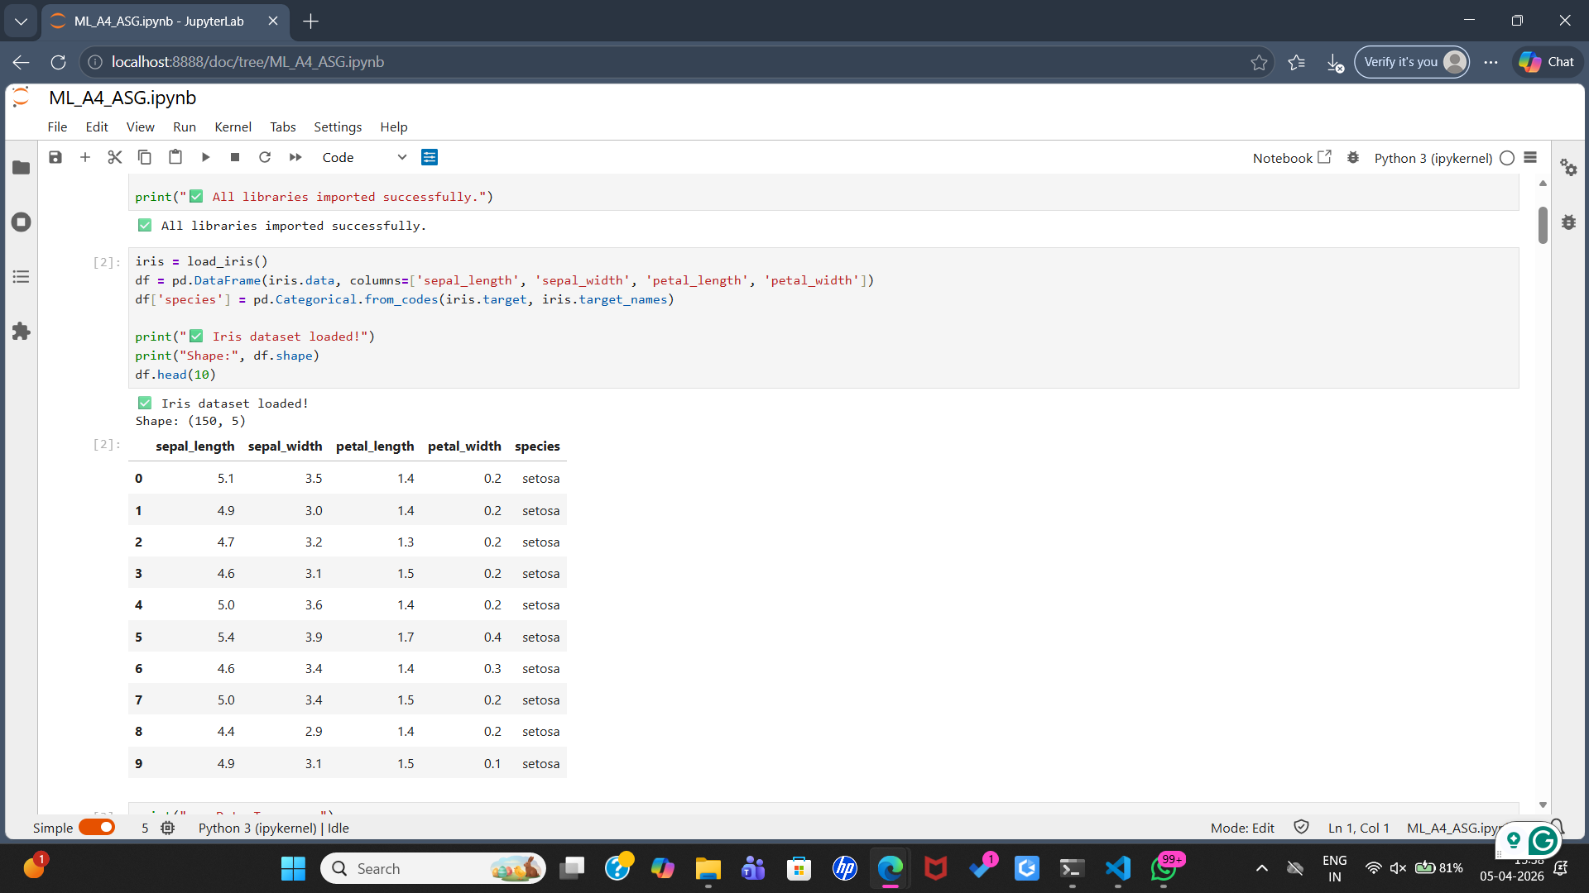






’
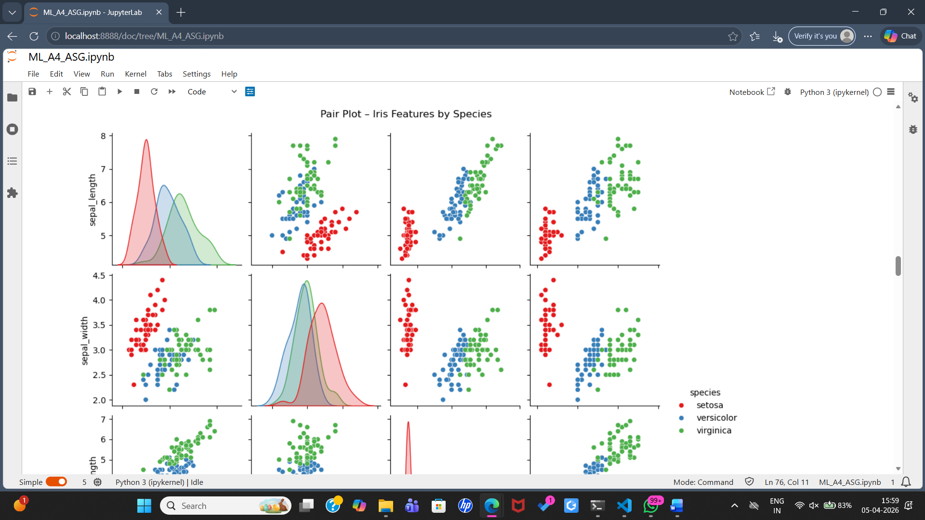

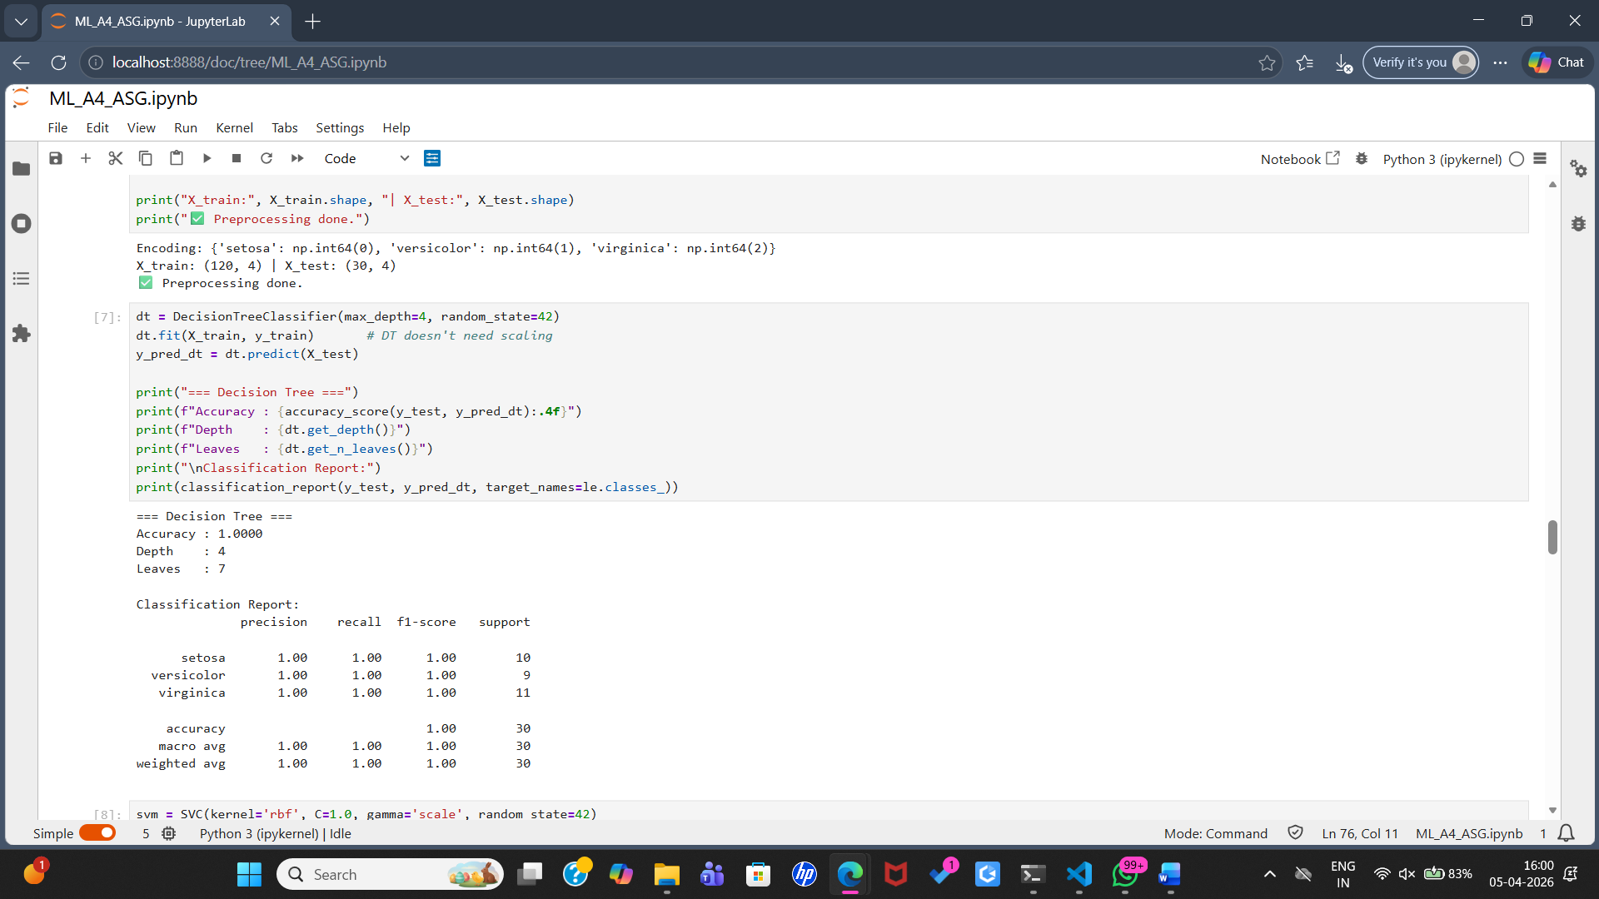

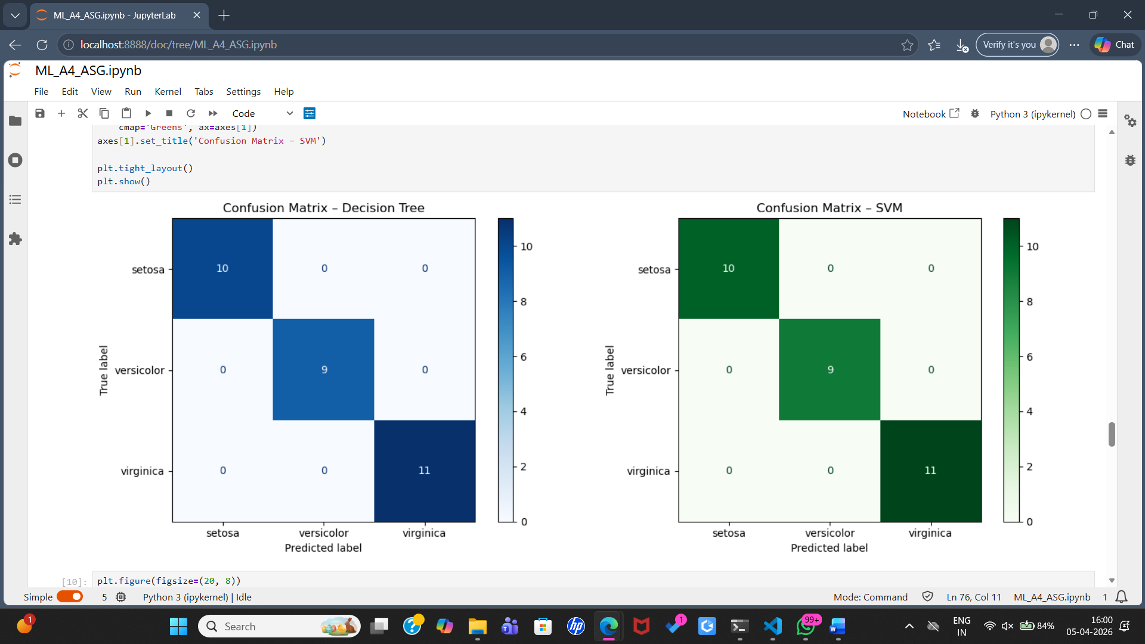
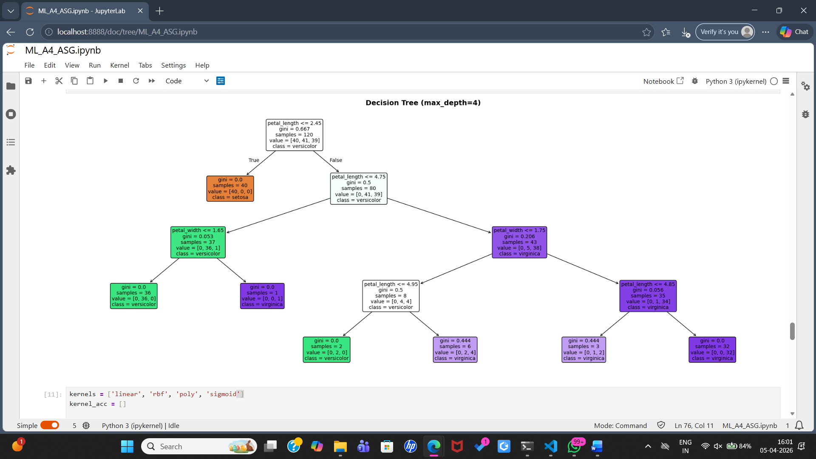
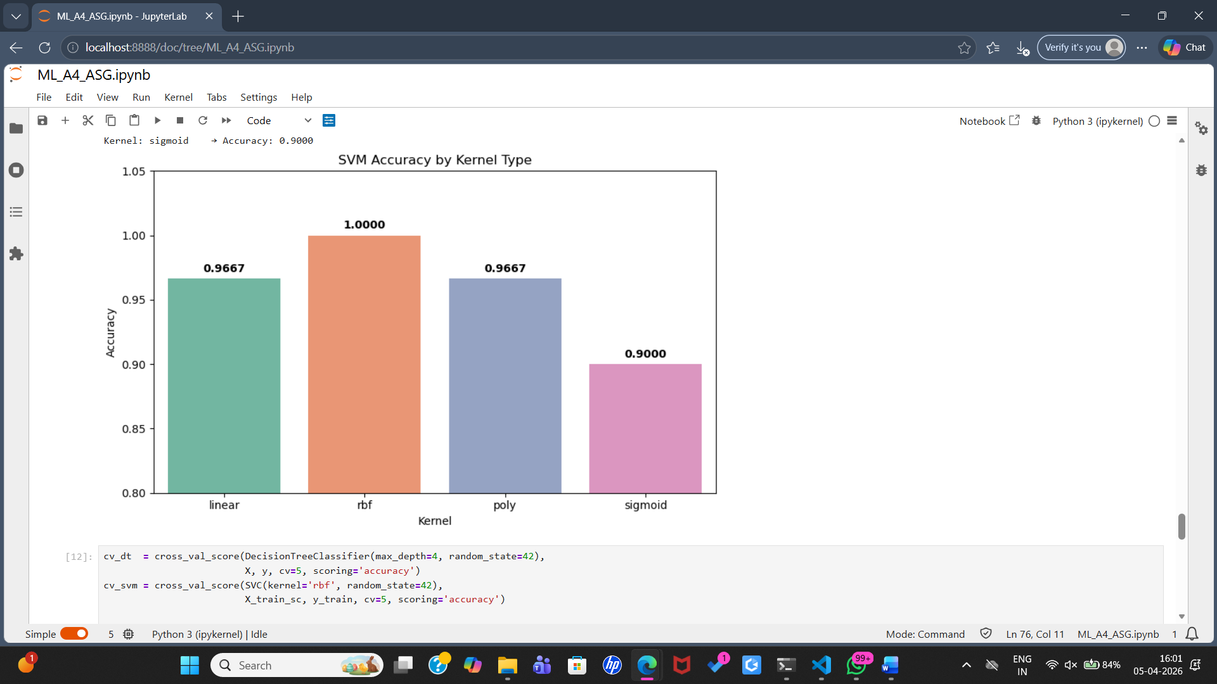

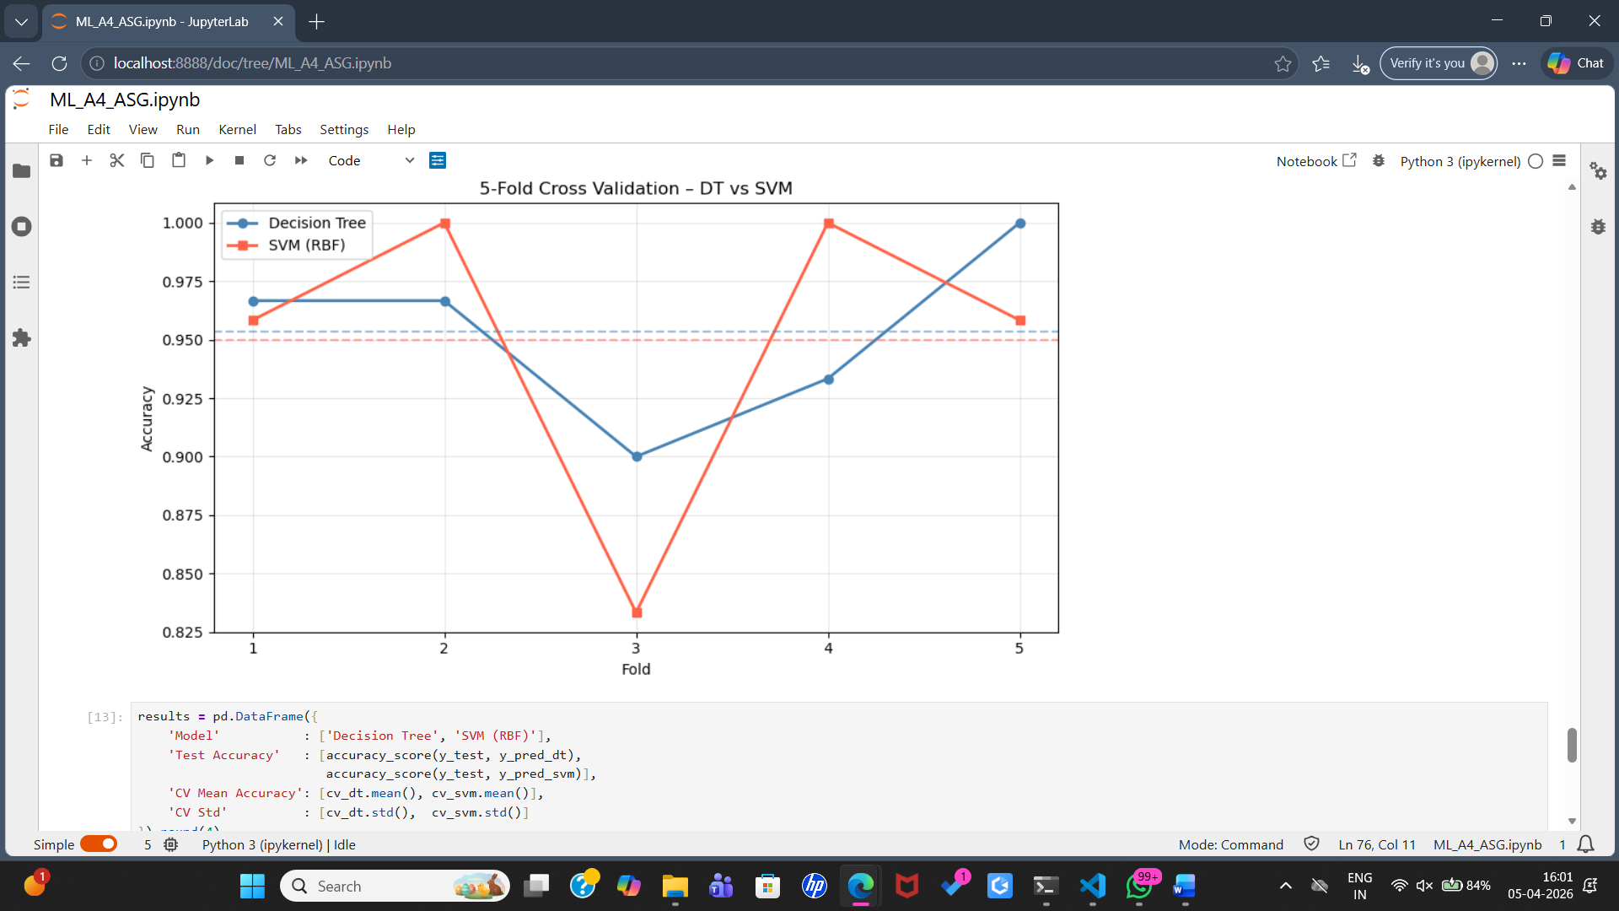

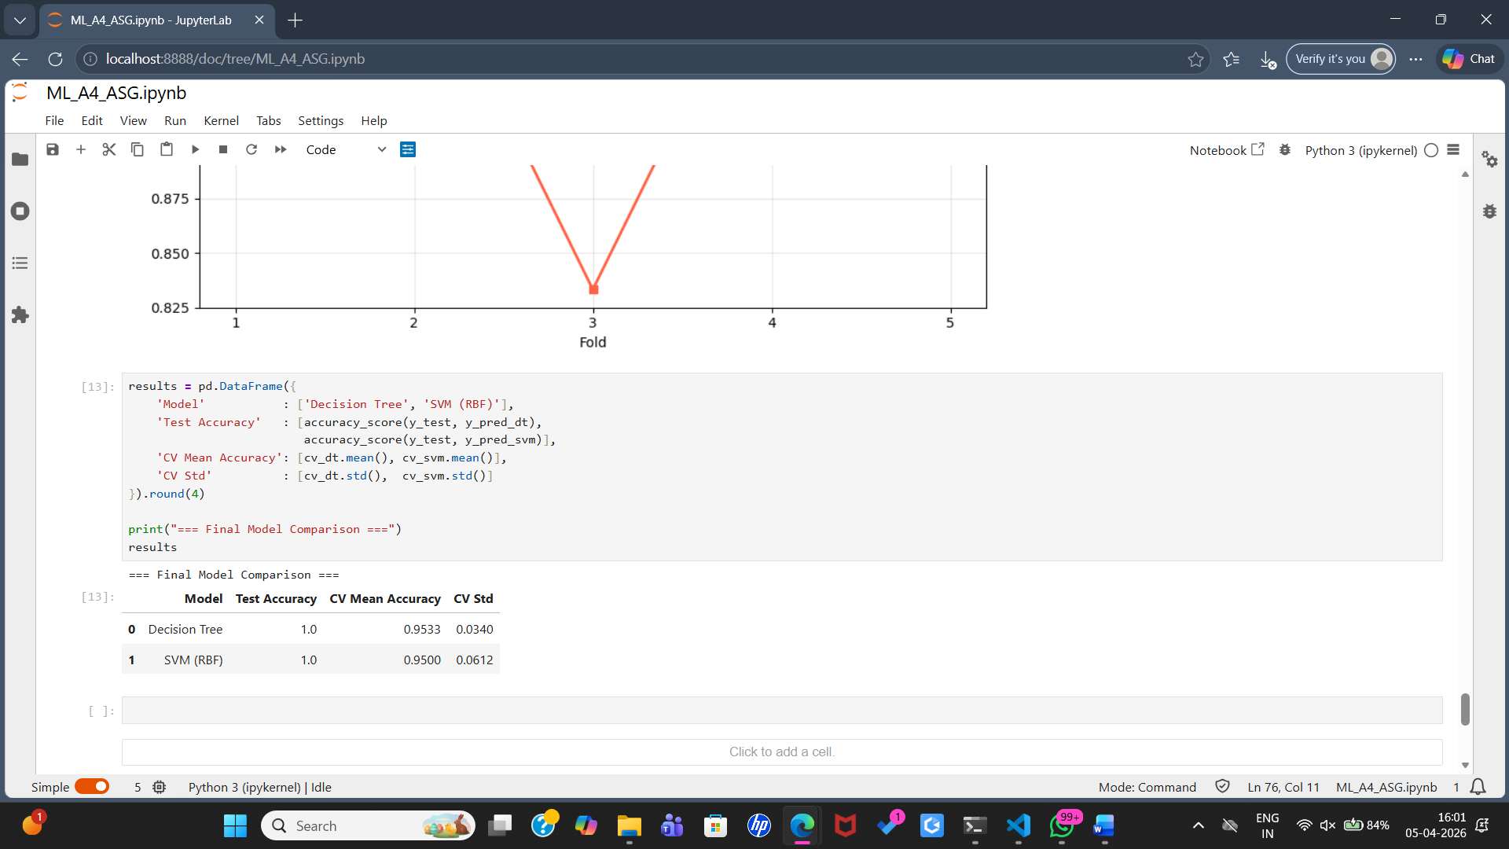

Conclusion:
In summary, SVM is a good choice when the data is separable and you want a black-box model that is less prone to overfitting. Decision tree is a good choice when the data is not separable and you want a more interpretable model.

FAQs:
What is a Classifier?
Compare SVM with decision tree classifiers.
How would you tune SVM parameters?
Describe various types of kernel functions.
Give the applications of SVM classifier.
State the significance of the kernel function.

